COMS Renewal Instructions
- Go to the COMS website at https://coms.hms.harvard.edu/
- Click the button that says Click Here to Login Using Harvard PIN
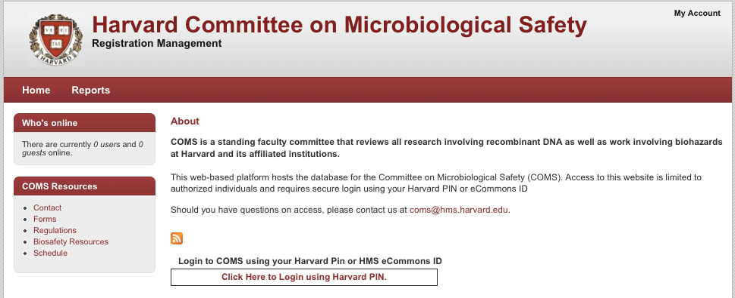
- You will be taken to the Harvard PIN login page, where you will be able to login using either your HUID and PIN or eCommons credentials
- Once logged in, place the mouse pointer over Registrations at the top of the page, then click Renewals, which will appear beneath
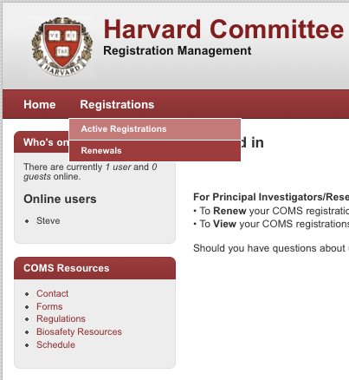
- A list of all registrations in need of renewal will then display
- Click on a title to renew that registration
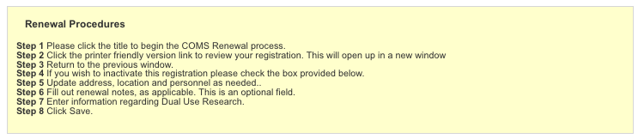
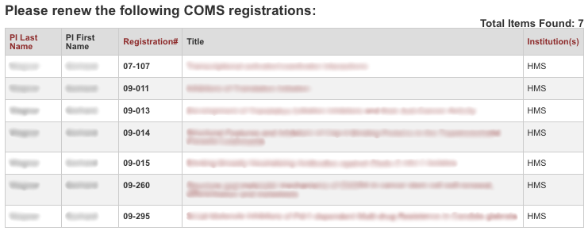
  - Click Next, Last, or page numbers at the bottom of the screen to see other pages of registrations
- After selecting a registration, you will be able to edit address, location, and personnel information
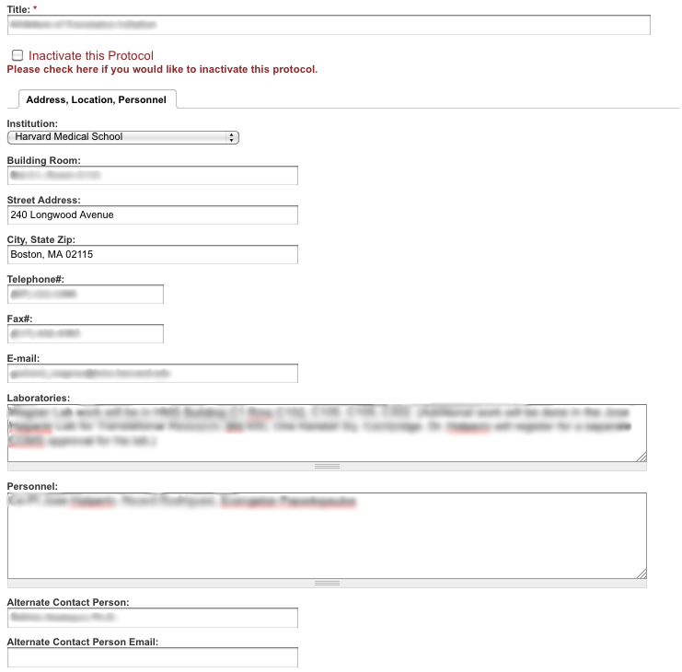
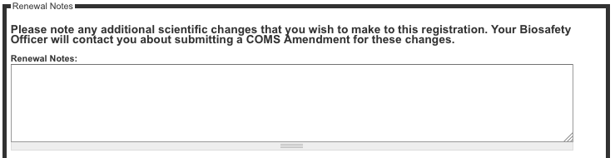
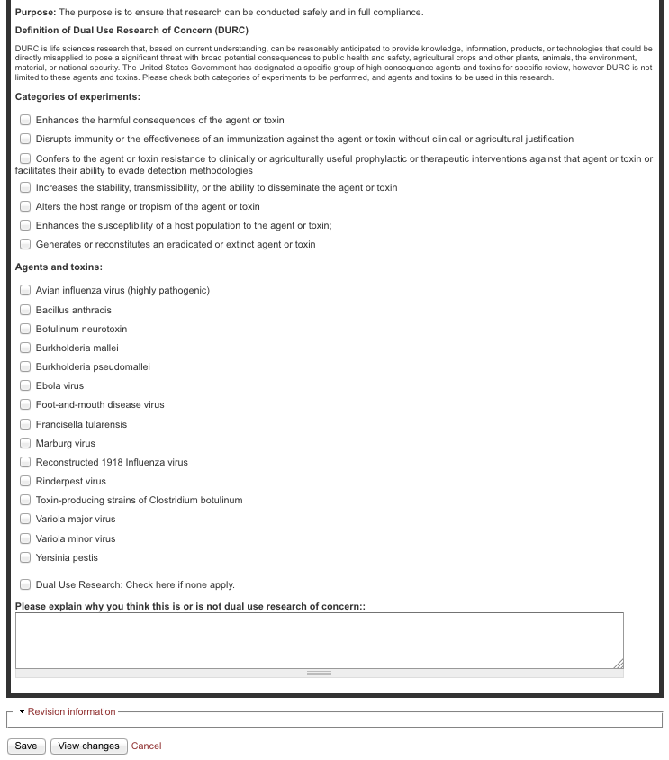

- Any additional scientific changes that you wish to make to this registration must be detailed in the Renewal Notes section at the bottom of the page
  - Your Biosafety Officer will contact you about submitting a COMS Amendment for these changes.
- Once all of the information has been updated, click Save at the bottom of the page to send to COMS
  - A message will display indicating that the renewal has been completed
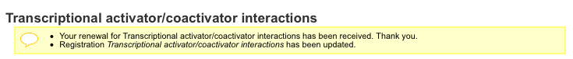
- To view additional registrations that need to be renewed, place the mouse pointer over Registrations at the top of the page, then click Renewals which will appear beneath
  - Any registrations that have already been renewed or not due for renewal if they are less than 1 year old will not display in the list

